**Mozambique – HDDS Modality Comparison**

The Household Dietary Diversity Score (HDDS) is an international proxy measure of household’s socio-economic status.

In order to validate this indicator for remote mobile-based data collection, WFP’s Vulnerability Analysis and Mapping (mVAM) team tested the feasibility of collecting the HDDS indicator using the Computer-Assisted Telephone Interviewing (CATI) method in Mozambique. The data for this study was collected in June – July 2017 from two provinces in Mozambique – Gaza and Inhambane.

In order to test if respondents’ answers changed significantly depending on the mode of data collection (face-to-face versus CATI), results from the annual face-to-face (F2F) Mozambique Secretariado Técnico de Segurança Alimentar e Nutricional (SETSAN) assessment (conducted in June/July 2017) were compared with results from the CATI survey.

It is important to note that the SETSAN assessments were only conducted in rural areas; whereas, for the CATI survey, respondents were asked to self-report whether they lived in a rural or urban area. Only those who self-reported living in a rural area were included in the test.

The SETSAN sample is 962 respondents, while the CATI sample is 464 respondents.

**Structure of the F2F and mVAM questionnaires**

***Face-to-face Questionnaire***

SETSAN surveys are designed to provide data on the food security and vulnerability situation of rural populations in Mozambique. The household questionnaire, which collects information at the household level, includes many modules including demographics, education levels, negative coping strategies, household expenditures, agriculture, food consumption, food assistance, and nutrition.

***mVAM Questionnaire***

In order to mitigate any potential biases between results obtained using the two data collection modes (F2F and CATI), the questionnaires for CATI and F2F assessment were harmonized. However, the mVAM questionnaire was kept relatevely short, withoperators taking approximately 10 to 15 minutes to complete one survey.

The mVAM questionnaire was divided into three main sections:

* *Section 1*: contained questions on household demographics and location.
* *Sections 2 and 3*: contained questions on household food consumption, coping strategies used, shocks faced by the households, and the provision of food assistance.

Both phone and F2F interviews were conducted in Portuguese and in local languages.

**The Household Dietary Diversity Score (HDDS)**

The HDDS is used as a proxy measure of the socioeconomic level of the household. HDDS ideally looks at the number of 12 unique food groups (cereals and grains; roots and tubers; vegetables and leaves; fruits; meat/poultry/offal; eggs; fish/seafood; pulses/legumes/nuts; milk/milk products; oil/fats; sugar/honey; and miscellaneous) consumed by household members in the home or outside the home and that were prepared over a 24-hour period. Studies have shown that HDDS is a useful approach for measuring the household’s ability to acquire sufficient a quality and quantity of food to meet the nutritional requirements for their productive lives.

**O*pen* versus list-based approach in the rural CATI data**

Two different methods were used to collect HDDS with CATI: *open recall and list-based*.

**Introduction to the methods of the HDDS data collection in the CATI survey**

**OPEN RECALL METHOD**

The open-recall method helps respondents to better recall all foods and beverages consumed the previous day and night by simply asking them to recall food items consumed the previous day. It also probes for main ingredients in mixed dishes (i.e., if someone says they ate “soup, the interviewer asks the respondent to explain the key ingredients in the dish). This approach is called “open,” because operators do not read predefined food group questions to respondents. Instead they ask what foods were eaten the day before the interview during the day and/or night, at home or anywhere else, breaking it down by different times of the day. For example:

*1: Yesterday, what did you or anyone in your household eat in the morning when you woke up (for breakfast)?*

*2: Yesterday, what did you or anyone in your household eat in the afternoon for lunch?*

*3: Yesterday, what did you or anyone in your household eat at night for dinner?*

For each eating “episode”, after the respondent mentions foods and beverages, the operator would probe again by asking if the respondent ate anything else. The operator would continue probing until the respondent says “no, nothing else”. Once the respondent finishes recalling foods eaten and beverages consumed, the operator notes all the corresponding food groups and re-checked with the respondent whether she/he ate any foods from groups that were not mentioned/checked.

**LIST-BASED METHOD**

In the list-based method, the operator reads a list of 12 “yes” or “no” pre-defined questions to the respondent. The pre-defined questions are on different foods groups consumed during the 24-hour period before the interview. When operators inquire about each food group, they give multiple examples for items within that specific food group. For example:

*Did you or anyone in your household eat cereals and grains including maize, maize meal, rice, wheat, pasta, bread, biscuits, sorghum, and millet yesterday during the day or night?*

**Analysis of the HDDS score collected using CATI (Open vs List)**

In order to assess if these two different approaches of data collection produce similar results, we compared the HDDS scores produced using the “open” and “list” approaches.

A total number of 460 rural respondents from Gaza and Inhambane Provinces were reached through an external call center. In both provinces, half of the surveyed respondents were asked to name the foods they had eaten in the previous 24 hours (open approach), while the other half were asked to pick food groups from a list (list-based approach).

As illustrated in Figures 1, 2 and 3, there are no significant differences between the means of the HDDS score produced using the “open” approach and the “list” approach for the sub-sample of rural respondents within the two provinces (Gaza and Inhambane). Overall, the mean HDDS is 6 for the list approach and almost 7 for the open approach. At the province level, the HDDS was 6 in the Gaza Province and 7 in the Inhambane Province for both approaches.

***Figure 1: Distribution of the HDDS score, rural respondents– June/July 2017***

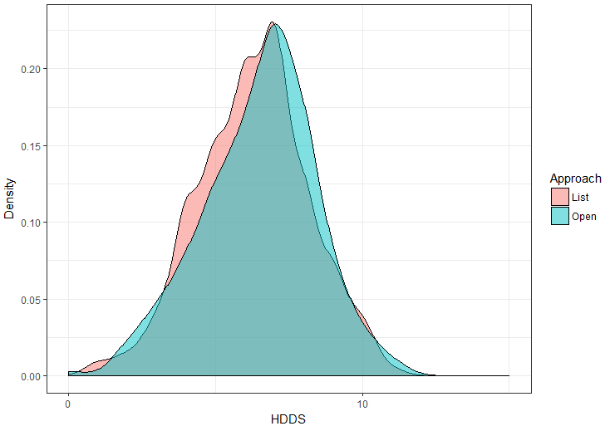

***Figure 2: Box-plot of the HDDS score, rural respondents– June/July 2017***

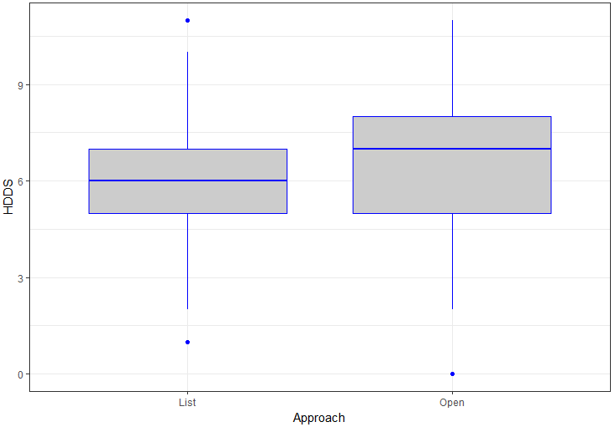

***Figure 3: Box-plot of the HDDS score by province – June/July 2017***

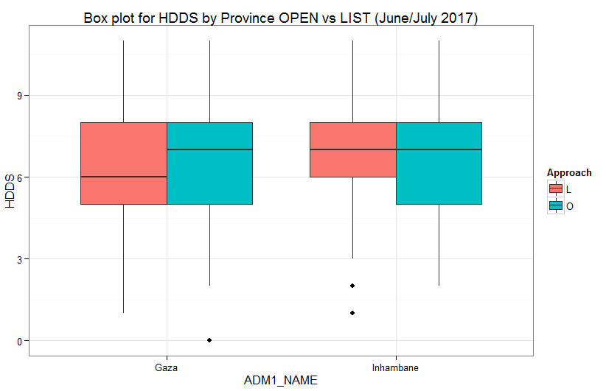

To validate the above results, an ANOVA model was implemented, and no significant differences were found between the two approaches. The difference between the mean HDDS across the two approaches (open and list) is 0.2.

In addition, no significant differences were found in the proportion of households who consumed *cereals, roots, fruits, meat, fish and sugar* between the two approaches (open and list). That said, a higher percentage of respondents interviewed using the “list based” method reported eating more eggs, dairy and condiments, and a lower percentage of respondents reported eating less pulses and vegetables compared to respondents interviewed using the “open-based” method (Figure 4).

***Figure 4: Percentage of households who consumed specific food items in the previous 24 hours***

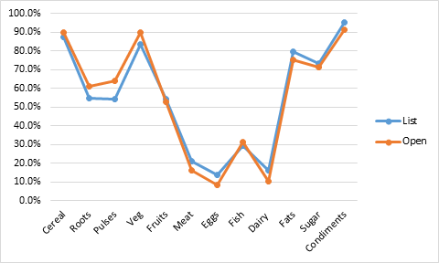

Since the results do not reveal any statistically significant differences in the Household Dietary Diversity Score (HDDS) from the two groups of respondents who were interviewed using the two different approaches (open and list), the data from both groups was aggregated when comparing the results with those collected via face-to-face data collection.

**HDDS mode test (F2F vs CATI) for the June/July 2017 survey**

We then compare the combined results from the June and July 2017 CATI list and open samples with the F2F[1] survey to better understand any differences that occurred between the two modalities.

## **Samples**

Before looking at the HDDS results obtained with different survey methods, we analyzed and compared the sample’s demographics in an attempt to identify any significant differences that could affect the HDDS score. In particular, we compared the two samples—along with their significance values— for gender, income sources, and shocks faced to quantify the differences across the F2F and CATI samples.

***Table1. Population's proportions in F2F and CATI surveys***

|  |  |  |  |
| --- | --- | --- | --- |
| ***Variable*** | ***F2F*** | ***CATI*** | ***p-value*** |
| ***Sex of head of household (M)*** | 66.8% | 69.0% | 0.42 |
| ***Gender of respondent (M)*** | 19.4% | 47.6% | 3e-28*** |
| ***Age of respondent in years*** | - | 39 | - |
| ***Income source (Ag+Fish)*** | 63.8% | 45.7% | 8e-11*** |
| ***Income source (Assist + Casual)*** | 9.8% | 18.1% | 0e-6*** |
| ***Income source (Salary)*** | 13.8% | 16.2% | 0.24 |
| ***Income source (SelfEmploy)*** | 12.6% | 20.0% | 2e-4*** |
| ***Shocks (death + illness)*** | 3.7% | 26.3% | 5e-37*** |
| ***Shocks (drought)*** | 40.3% | 9.5% | 2e-32*** |
| ***Shocks (food+cyclone)*** | 15.9% | 5.6% | 4e-8*** |
| ***Shocks (HoH death)*** | 0.004% | 0.002% | 0.55 |
| ***Shocks (job loss)*** | 1.2% | 7.5% | 4e-10*** |
| ***Shocks (none)*** | 38.4% | 50.9% | 8e-6*** |
| *p-value reported symbol*  *0.10 to 0.05\**  *< 0.05 to 0.01 \*\**  *< 0.01 \*\*\** |  |  |  |

*Table 1* above shows that the two samples differ in their composition in terms of the gender of the respondent and income source. Furthermore, it also shows that the shocks felt by respondents differ significantly across the two survey methods. This could, however, could be in part due to the fact that the recall period for each of the surveys was different: 12 months for the F2F and 1 month for the CATI.

***S*ex of the head of the household and gender of the respondent**

We found a difference between the gender proportions of the respondent and the gender proportions of the head of the household between the two surveys. The causal factors behind such a difference in the gender of the respondent could imply that:

* It is easier to reach females in the face-to-face survey, because they are more likely to be at home while the male is at work or more likely to respond to a face-to-face survey.
* The owner of the phone in rural households is more likely to be male.

**Figure 5. Household Gender proportions in the F2F and CATI surveys**

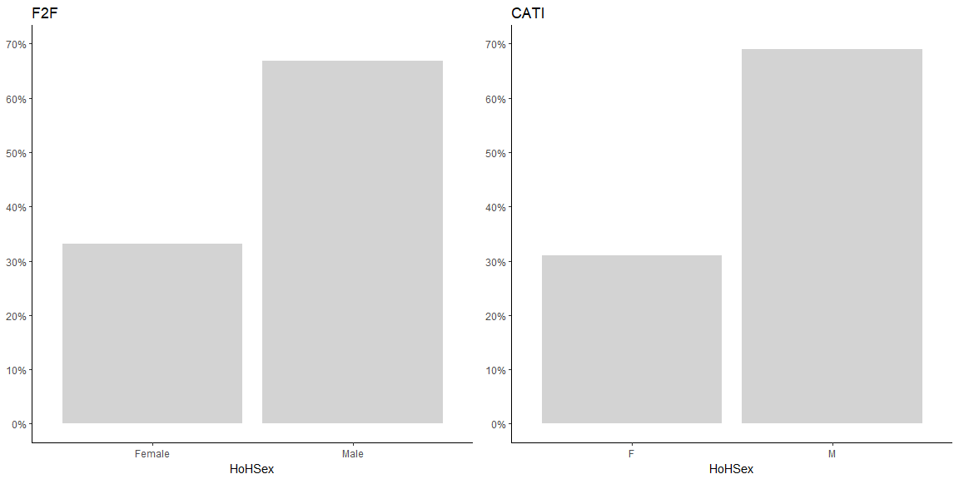

### **Income source distribution**

As illustrated in *Table 1* and *Figure 6*, one major difference between the F2F and CATI samples arises from the sources of income of the household. While in both cases the primary source of income of the household was either agriculture or fishing, the proportions of households relying on each source varied greatly (~18%) between the two modalities, with more households relying on fishing and agriculture in the F2F group (18%) than in the CATI sample.

***Figure 6. Income source proportions in the F2F and CATI surveys***

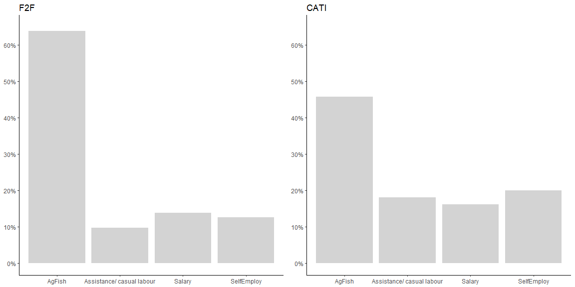

### **Shock distribution**

We also examined the shocks felt by the respondent in the period preceding the interview. The questionnaire in the F2F case has a higher number of options when answering this question. However, these were easily aggregated into similar answers as in the CATI survey. Once standardized, we compared the proportions of households that faced different types of shocks.

**Figure 7. Proportions of shock types in F2F and CATI surveys**

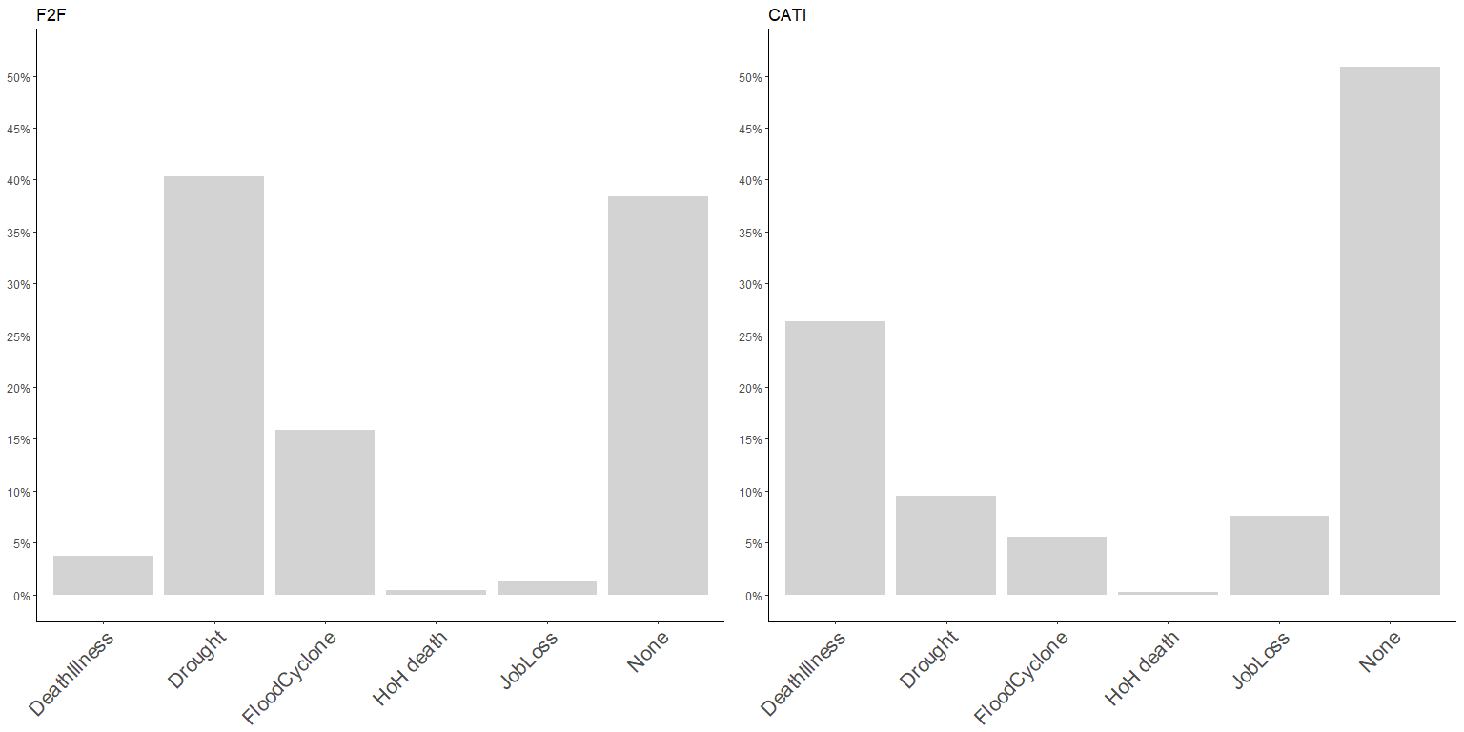

Based on our findings, climate issues were the main shock reported by respondents during the F2F round. Death or illness was also reported as a major concern for respondents interviewed via the CATI survey, even though the F2F survey provided more granular data on this topic. One reason explaining the much higher proportion of households affected by climate issues in the F2F survey may be related to the higher proportion of the population dependents on agriculture or fishing in this sample. Although the differences are statistically significant, conclusions on this variable are, however, to be interpreted with caution, as the recall period for shocks in the F2F survey is 12 months against a one-month recall period for the CATI survey.

### **Roof type and toilet type distribution**

Variables ToiletType and RoofType are commonly used as proxies for assessing the living conditions of survey respondents. That said, the same living conditions indicator question was not asked for both surveys. Instead, ToiletType is used in the CATI questionnaire while RoofType is used in the F2F. In order to make use of these variables to compare the living conditions between the two samples, they are categorized into two classes, *Better Off* and *Worse Off*, as follows:

***Table2. Toilet Type and Roof Type categorization***

|  |  |  |  |
| --- | --- | --- | --- |
| ***Roof Type*** | ***Category*** | ***Toilet Type*** | ***Category*** |
| *Grass/Sticks* | **Worse Off** | *Traditional unimproved latrine* | **Worse Off** |
| *Plastic/Canvas* | **Worse Off** | *Improved traditional latrine* | **Better Off** |
| *Zinc* | **Better Off** | *Improved latrine* | **Better Off** |
| *Cement* | **Better Off** | *West type no flush* | **Better Off** |
|  |  | *West type with flush* | **Better Off** |
|  | |  |  |

We found a strong disparity in the living conditions between F2F and CATI respondents in terms of toilet type and roof type (see *Figure 8*). Although we cannot reply on these numbers to prove a statistically significant difference in the two samples given the different wealth proxy indicators used, the results tend towards the pattern we have observed until now: the CATI sample generally reaches a population that is overall better off than the F2F population.

***Figure 8. Living standards proportions between F2F and CATI surveys***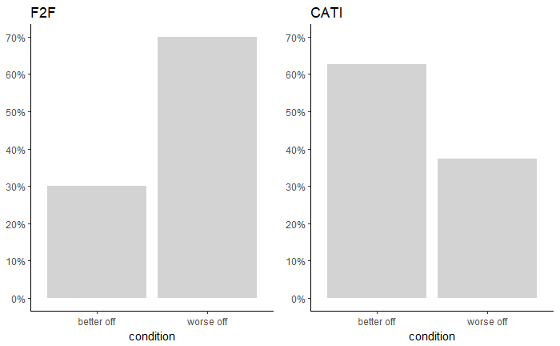

***Figure 9. Age distribution in the CATI sample***

## Indicators

Due to the significant differences in the two samples’ demographics, we can expect to observe different results for the Household Dietary Diversity Score (HDDS) between the F2F and CATI surveys. In *Table 3* and *Figure 12* below, we observe both the distributions and means of the HDDS scores for the two survey modalities.

***Figure 10. HDDS scores of the CATI and F2F surveys***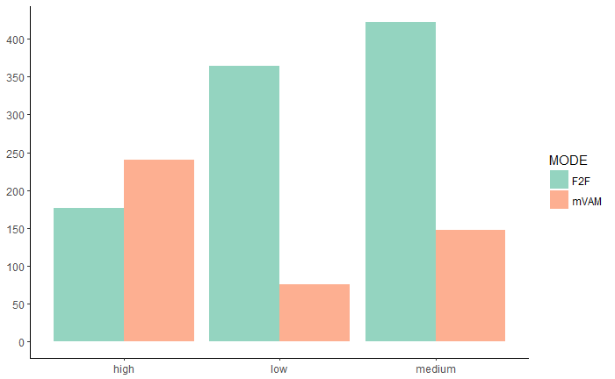

***Table 3. HDDS means of F2F and CATI surveys***

|  |  |  |  |  |
| --- | --- | --- | --- | --- |
| *dataset* | *variable* | *Mean* | *CI* | *p-value* |
| *F2F* | HDDS | 5 | 3 | 2.86E-36 |
| *CATI* | HDDS | 6 | 4 |

In the F2F survey, we have a sample that is generally worse off or more prone to food insecurity. The measured HDDS index reflects this sample with worse access to diverse foods among F2F households. HDDS is, on average, 1.4 points lower in the F2F results as compared to the CATI results. This is likely because more females were contacted, and they likely have more insecure sources of income that were affected by climate issues. Furthermore, if we consider the *ad-hoc* worse-off/better-off categorization determined from the toilet types and roof types reliable, then people within the F2F survey tended to have a lower standard of living. According to HDDS guidelines (1),

“In the absence of income or economic data from the baseline survey, a HDDS target can be established by taking the average diversity of the 33 percent of households with the highest diversity (upper tercile of diversity).”

We computed the target from the top 33% of the HDDS scores for the CATI and F2F samples and set them as food-diversity targets. The results confirm our previous findings and highlight a larger proportion of households with low food diversity in the F2F sample compared to the CATI sample.

***Table 4. HDDS targets for F2F and CATI surveys***

|  |  |  |
| --- | --- | --- |
| *Variable* | *F2F* | *CATI* |
| mean HDDS of the top 33% group | 7 | 8 |
| sample’s population below target | 81.7% | 72.6% |

***Figure 11. Comparison of HDDS groups against sample’s targets***

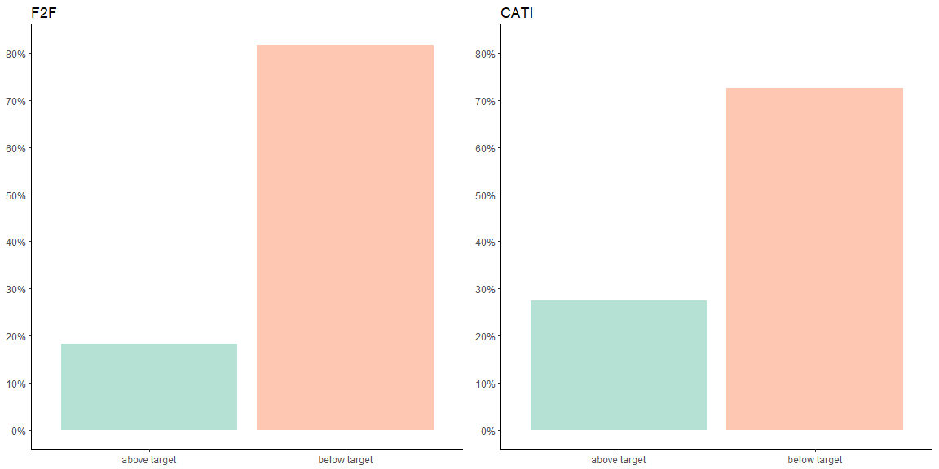

### Food Groups

Digging deeper into the variations within the 12 food groups used to produce the HDDS index, we compared whether a particular food-type was consumed in the day prior to the survey. We assumed here that the day of the week when the survey was carried out is distributed equally within the week across the two surveys.

***Figure 12. Food group frequencies in the CATI and F2F surveys***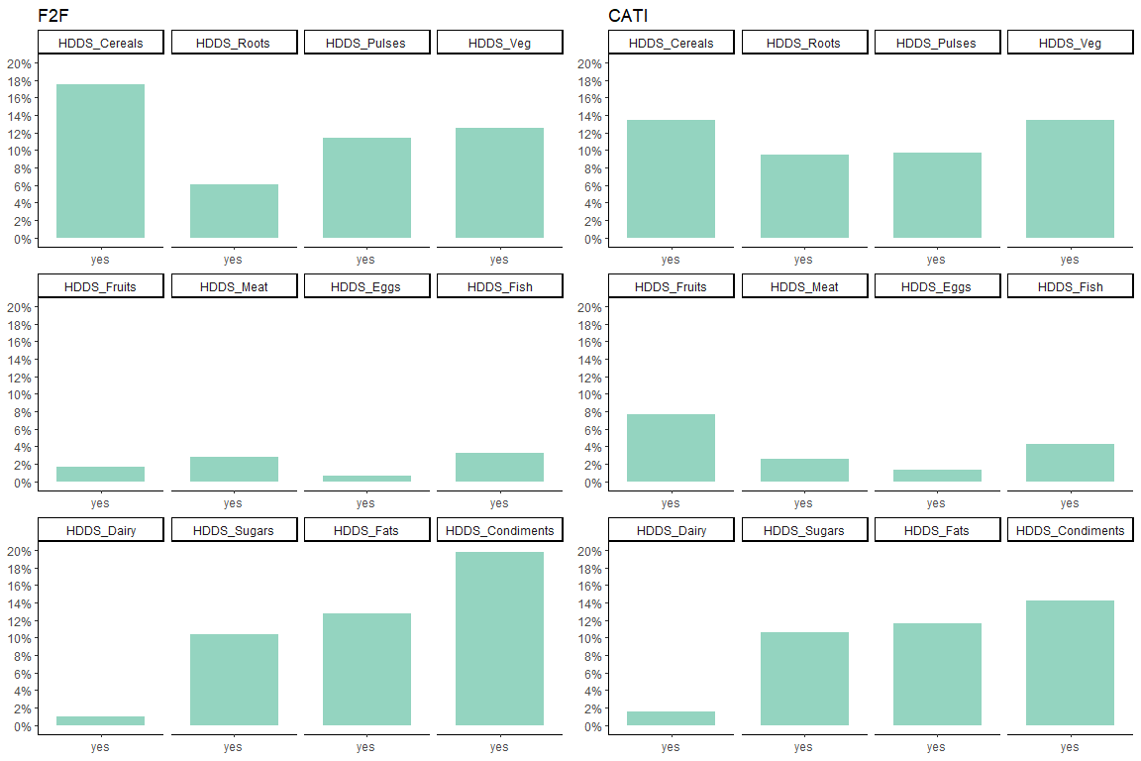

In *Figure 12,* we observe that, in the CATI sample, there is a higher consumption of roots, vegetables, and fruits, which is indicative of higher dietary diversity compared to the F2F sample. This result is even more significant when we note that the F2F responses for fruits and vegetables is an aggregate of multiple questions (green, orange and other vegetables, orange and other fruit). Typically, asking more questions tends to push the responder to a higher level of recollection of what he/she consumed during the recall period. Thus, we would typically expect a higher score for these categories for F2F as opposed to a lower one.

## Conclusions

When comparing the results between the CATI and F2F surveys, we observed found sample populations with significant differences, from the gender of the respondents to their primary income sources and shocks. This is usually the case when using the phone to reach respondents, as there tends to be a bias due to the fact that our sample is derived from solely a population that owns a phone. The HDDS scores measured in the two samples also differ. We can deduce that the higher HDDS score observed for the CATI survey reflects the generally better-off sample reached compared to those reached via the F2F population sample.

**Limitations of the CATI survey**

During the initial survey training held at the call center, operators were randomly divided into two groups (Group A and Group B), where members of the Group A asked the HDDS questions using the list-based approach, while members of the Group B asked the HDDS questions using the open-based method.

However, during the CATI data collection, operators made calls for both Group A and Group B, even if their data entry tools were specific to the group to which they had been assigned. The movement of some operators from the open to the list-based approach was mainly due to absenteeism and the call center’s need to re-allocate operators to the other team. That said, despite these internal shifts, all operators adhered to the specific HDDS script requirements regardless of their movement from one survey approach to another. This was supported and closely monitored by the quality assurance department of the call center.

**References**

1. Swindale, Anne and Paula Bilinsky. *Household Dietary Diversity Score (HDDS) for Measurement of Household Food Access: Indicator Guide.* Food and Nutrition Technical Assistance Project, Washington, D.C. 2006.
2. FAO & FHI 360. *Minimum Dietary Diversity for Women: A Guide for Measurement*. (FAO, 2016).
3. Christine Lamanna, Kusum Hachhethu, Sabrina Chesterman, Gaurav Singhal, Beatrice Mwongela, Mary Ng’endo, Silvia Passeri, Arghanoon Farhikhtah, Suneetha Kadiyala, Jean-Martin Bauer, and Todd S. Rosenstock. *Limits of computer assisted telephone interviews (CATI) for nutrition data collection in rural Kenya.*
4. R Core Team. R: A language and environment for statistical computing. (R Foundation for Statistical Computing, 2015). Available at: [https://www.R-project.org/](https://www.r-project.org/)

1. The SETSAN survey used list-based approach to collect the HDDS indicator.